

722 Courtyard Drive
Hillsborough, NJ
Somerset County
Professional Office Condominium

Worden & Green

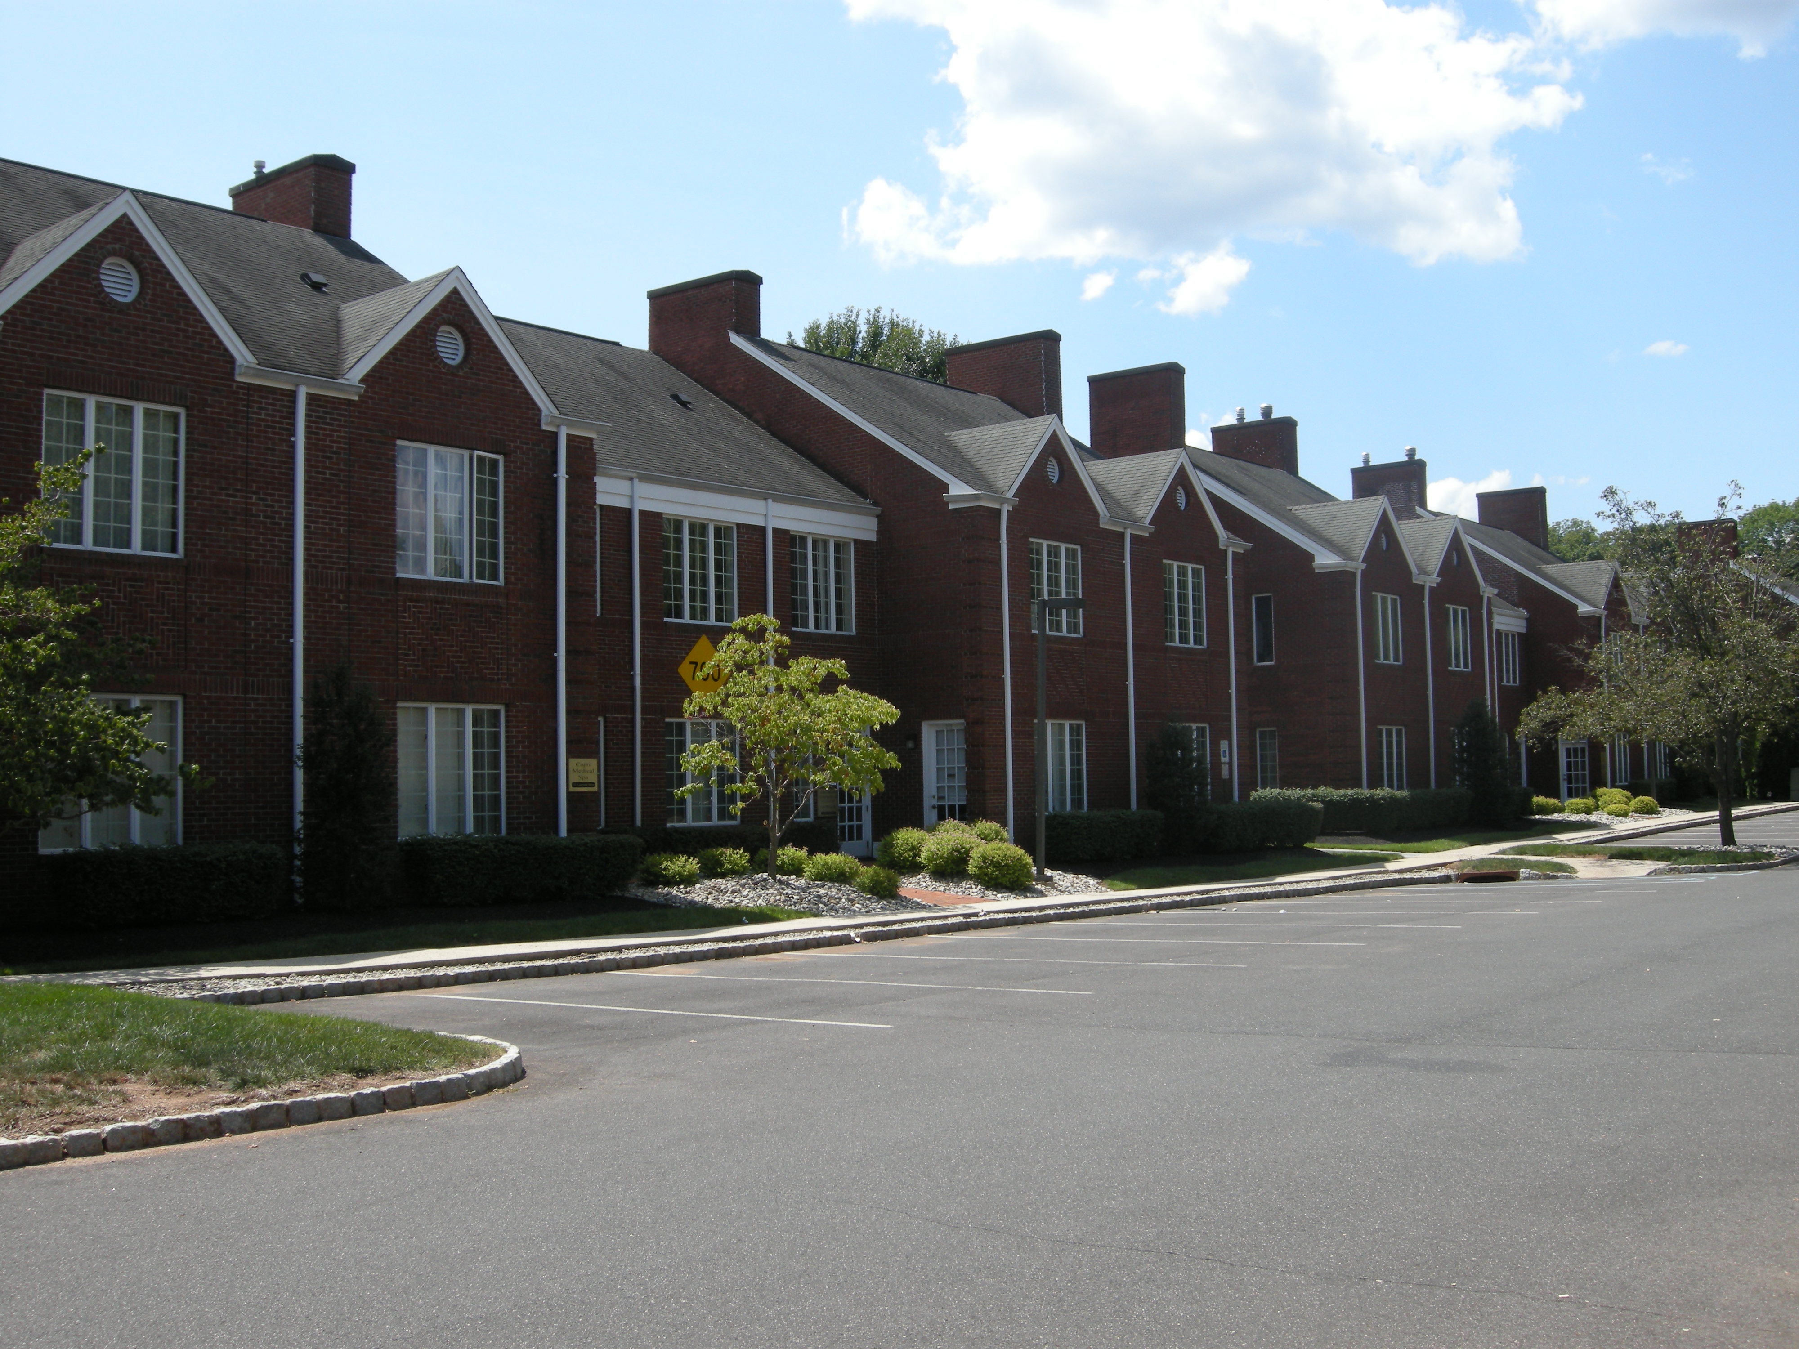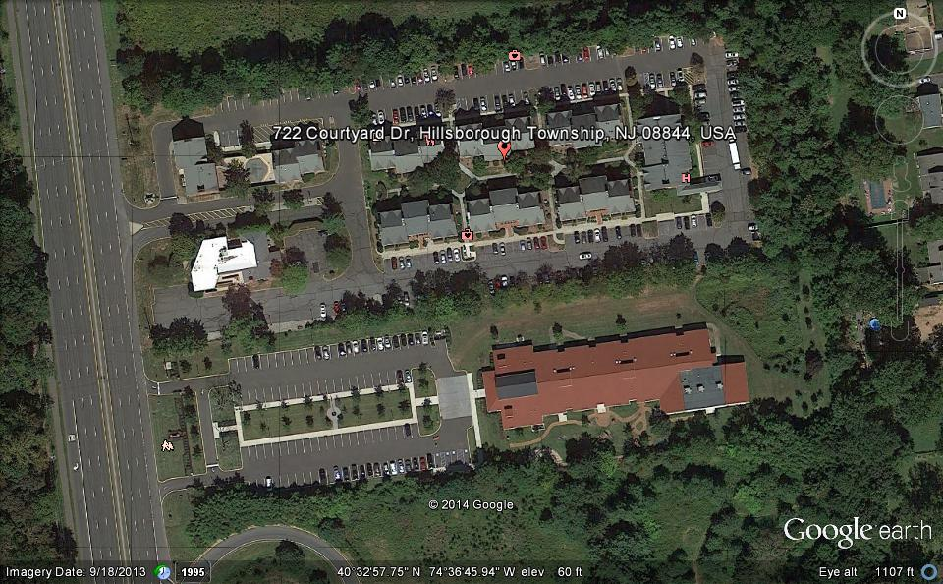
Offered At
$370,000

CENTURY 21 Worden & Green
256 Route 206 ~ Hillsborough, NJ ~ 08844
1070 Highway 18 ~ East Brunswick, NJ ~ 08816
Phone 908-874-4700 ~ 732-238-2100
www.century21wordengreen.com
Part of 70,000 square foot office complex known as Courtyard Hillsborough. 2640 sq ft ultra clean medical professional office complex. This unit is a second floor walk-up. It offers 4 offices, reception area, large and small conference rooms, kitchenette with a sink and private bathroom. 100% financing to qualified buyers. Minutes from Somerville, Somerville Circle,
Rt. 206, Rt. 28, Rt. 22, Rt. 287 and Rt. 78.

For more information contact:

All information deemed to be reliable, but not guaranteed.

Don Griffin
don.griffin@Century21.com
P: 908-874-4700 Ex:374
C: 732-284-6714
F: 908-874-6024
www.Century21.wordengreen.com
Number 1
Century 21
Commercial Office
in the Nation
Number 1
CENTURY 21
Commercial
Office in the
Nation

